Dear Manager:

For now the station of Rod and cylinder.
- About cylinder tube :
- The short cylinder all done. Inspection 6pcs, the data sheet attached. We try to follow the task file of
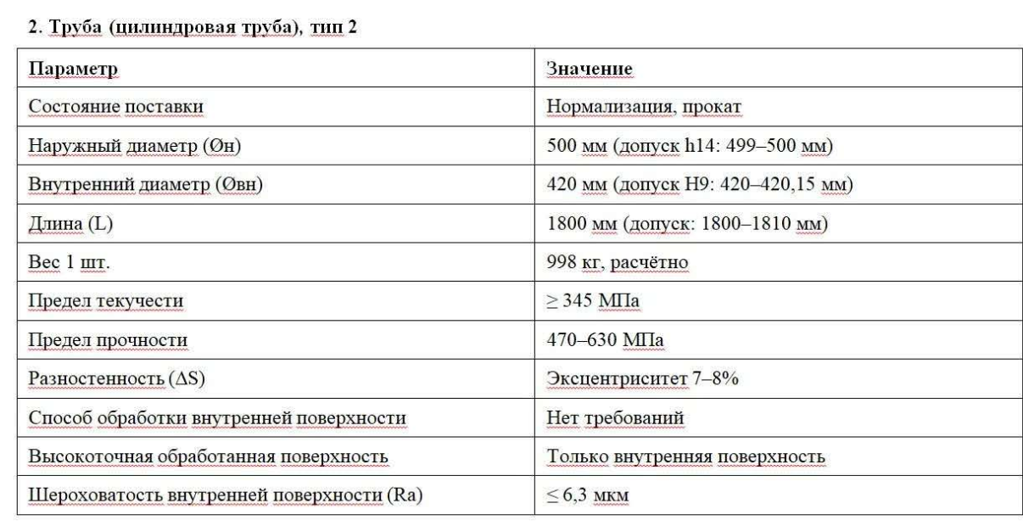

Video will make zip file send to you.
- The longer cylinder will make in 10days. That will not make 36xM22 hole. Only make the 2x18mm hole. Because this factory can not do screw. This factory is specificity make the Internal grinding, please check they dong the grinding is better than task standard.
Inspection parameter table attacked. We will check the longer tube following the table.

- So we will supply 8pcs short tube(1707-1710mm) and 4pcs longer tube(2184mm).

- About point rod:
Following your last request file.:

We checking the jump today:
No | Body | Ring 1 | Ring 2 | mm
1# | 15 | 18 | 18 | 0.170
4# | 3 | 5 | 4 | 0.040
5# | 7 | 7 | 8 | 0.073
6# | 15 | 15 | 12 | 0.140
9# | 15 | 15 | 12 | 0.140
10# | 15 | 12 | 8 | 0.117
11# | 12 | 12 | 12 | 0.120
14# | 12 | 11 | 10 | 0.110
16# | 3 | 2 | 5 | 0.033

Please check the video attached.
If pass we will repeat check other parameter.

1707cylinder inspection datasheet
no | STANDARD | NO 1 | NO 2 | NO 3 | NO 4 | NO 5 | NO 6 | NO 7 | NO 8 | Измерительные инструменты
1 | 500 мм (допуск h14: 499–500 мм) | 500  500 | 500.4  500.1 | 500.4  500.5 | 500.5  500.6 | 499.4  499.5 | 501  501 |  |  | Калибр
2 | 420 мм (допуск H9: 420–420,15 мм) | +0.07  +0.05 | +0.09  +0.08 | +0.04  +0.04 | +0.14  +0.14 | +0.11  `+0.12 | 0.13 |  |  | Внутренний диаметромер 250-450
3 | 1707 мм (допуск — ±0.5 мм)  ==》1710mm | 1710 | 1707 | 1710 | 1710 | 1710 | 1707 |  |  | 3-метровая рулетка
4 | Эксцентриситет 7–8% | 40.4 40.4  40.4 40 4 | 40.1 40.3  40.4 39.8 | 40.2 40.4  40.2 40.3 | 40.3 40.4  40.4 40.3 | 39.5 39.7  39.7 39.6 | 40.5 40.6  40.7 40.5 |  |  | штангенциркуль
5 | ≤ 6,3 мкм | 0.054  0.079 | 0.258  0.178 | 0.124  0.17 | 0.112  0.111 | 0.075  0.067 | 0.215  0.159 |  |  | Измеритель шероховатости и гладкости поверхности
6 | 36X450 | 34 | 35 | 35 | 35 | 35 | 35 |  |  | штангенциркуль
7 | 36X450 | 36 | 35 | 35 | 35 | 35 | 35 |  |  | штангенциркуль
8 | 2X450 | 1 | 1.5 | 1 | 1 | 1.5 | 1.5 |  |  | штангенциркуль
9 | 2X450 | 1.5 | 2 | 1.5 | 1.5 | 1 | 1 |  |  | штангенциркуль

